- Develop a system using UML for implementing Online Course Reservation System. This system is organized by the central management system. The student first browses and selects the desired course of their choice. The university then checks the availability of the seat if it is available the student is enrolled for the course.

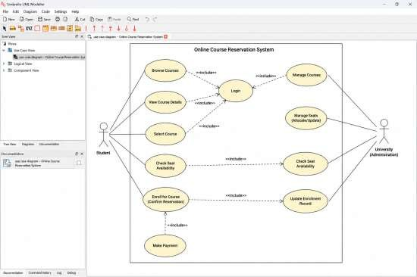

- Develop a system using UML for implementing E-Ticketing System. This is to be used by the passenger for reserving the tickets for their travel. This E ticketing is organized by the central system. The information is provided by the railway reservation system.

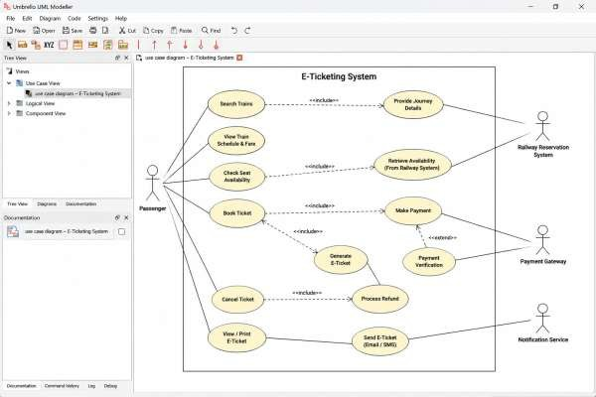

- Develop a system using UML for implementing Credit Card Processing System. In this system, the cardholder can purchase items and pays the bill with the aid of a credit card. The cashier should accept the card and proceed with the transaction using the central system. The bill is to be verified and the items are delivered to the cardholder based on it.
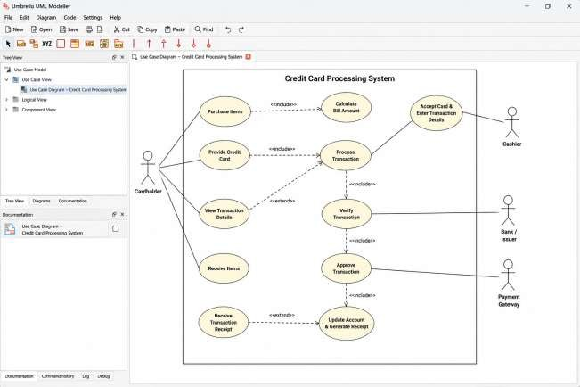

- Develop a system using UML for Software Personnel Management System. It should be used to process the details of a person who works in a software company. The details are to be stored in the central management system for cross-checking the person’s details.
